CKC Fuel & Expense Policy
Background
- We have a reliance on club members cars to transport kayaks and kit to paddling locations.
- We need a consistent approach to fuel and expenses so that the drivers and passengers understand the costs and how they will be apportioned and that neither are surprised or aggrieved.
The policy is described below with 3 scenarios of increasing complexity to demonstrate the application of the policy and clarify common situations. It is not feasible to document all the possible scenarios, particularly for longer trips, so the general approach should be applied where there is no specific guidance.
Fuel Costs
This policy applies to:
- Drivers using Internal Combustion Engine (ICE) vehicles only.
- Fuel costs will be shared where drivers are taking club boats, kit and/or passengers on club trips. Drivers (including motorbike riders) not taking boats, kit or people are not eligible for fuel cost sharing.
- Fuel costs will be shared for travelling outside of London only (i.e., more than 1 hour from Kew Bridge or more than 25 miles from Kew Bridge). For short trips around Kew Bridge (eg to Shepperton), the costs are borne by the car driver.
- Parking cost can also be added.
Mileage and costs will be calculated using the AA Mileage Calculator Mileage calculator | AA (theaa.com) which allows the cost of fuel and the miles per gallon (mpg) to be input. See the example below:
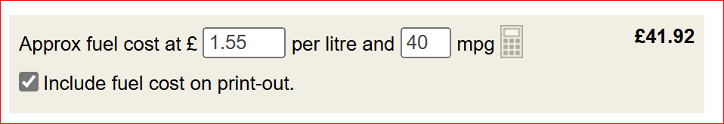
For trips where the driver is taking part, a further contribution to wear and tear expenses should be added at the rate of 10p per mile. The assumption is that the driver would be making this trip regardless of the number of passengers, so a limited contribution to expenses is made. See the example below:
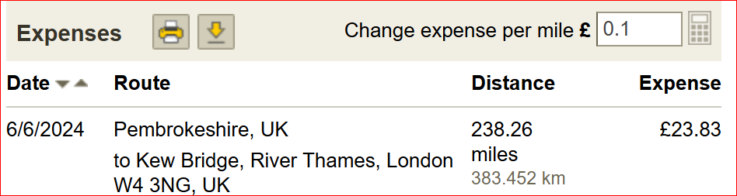
For trips where the driver is not taking part, the HMRC mileage rate will apply (Travel — mileage and fuel rates and allowances - GOV.UK (www.gov.uk)), currently 45p per mile. This may change each year and the current rate will apply. This rate includes the wear and tear costs and so no additional expenses should be added.
During the course of a club trip, if drivers use their car to transport passengers and/or kayaks to and from paddle locations, passengers should also expect to make a contribution to petrol costs based on the AA rate calculator. This is especially important when the location of day paddles require driving over 20 minutes each way.

Scenario 1 – simple trip to Lepe
- Liza takes 2 boats to Lepe and 2 passengers
- David takes 2 boats and no passengers
- Mike takes 2 boats and 1 passenger
- The distance is 87.21 miles (each way). There are 6 people on the trip.
- Mike and Liza’s cars are petrol, have an average of 38 mpg and fuel cost is £1.40.
- David’s car is diesel, has an average mpg of 40 and fuel cost is £1.55.
From the AA Mileage Calculator,
- Mike and Liza’s the fuel cost is £14.59 and the expense cost is £8.72
- David’s fuel cost is £15.34 and the expense cost is £8.72.
See below:
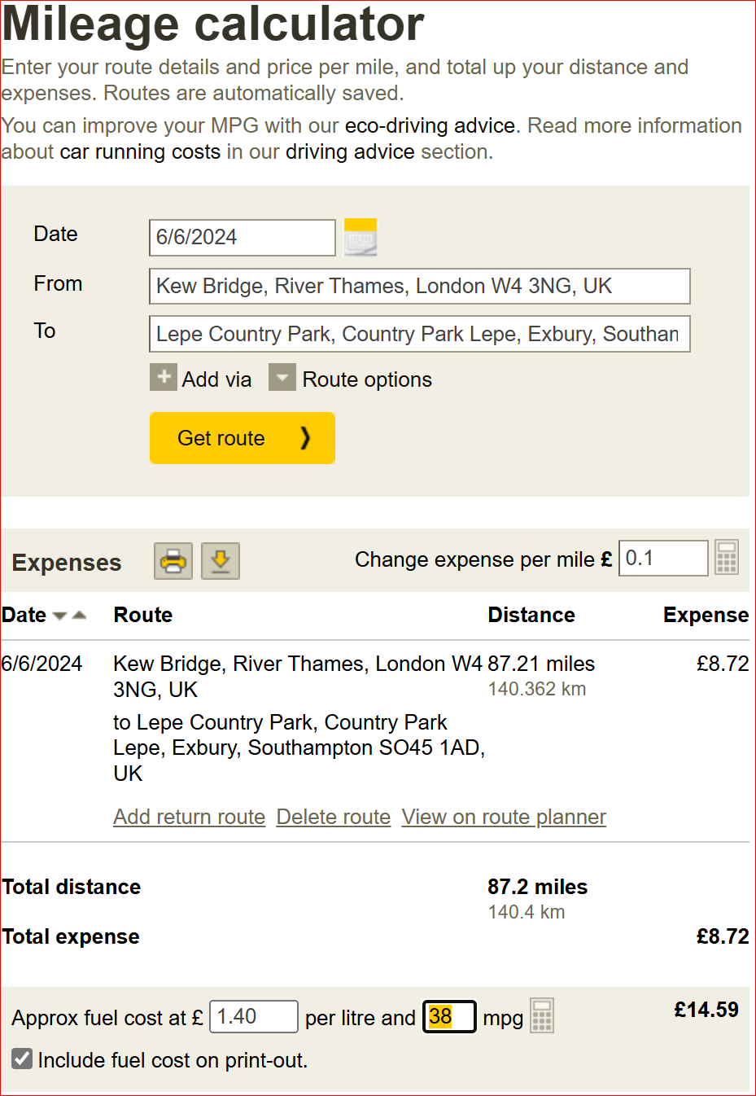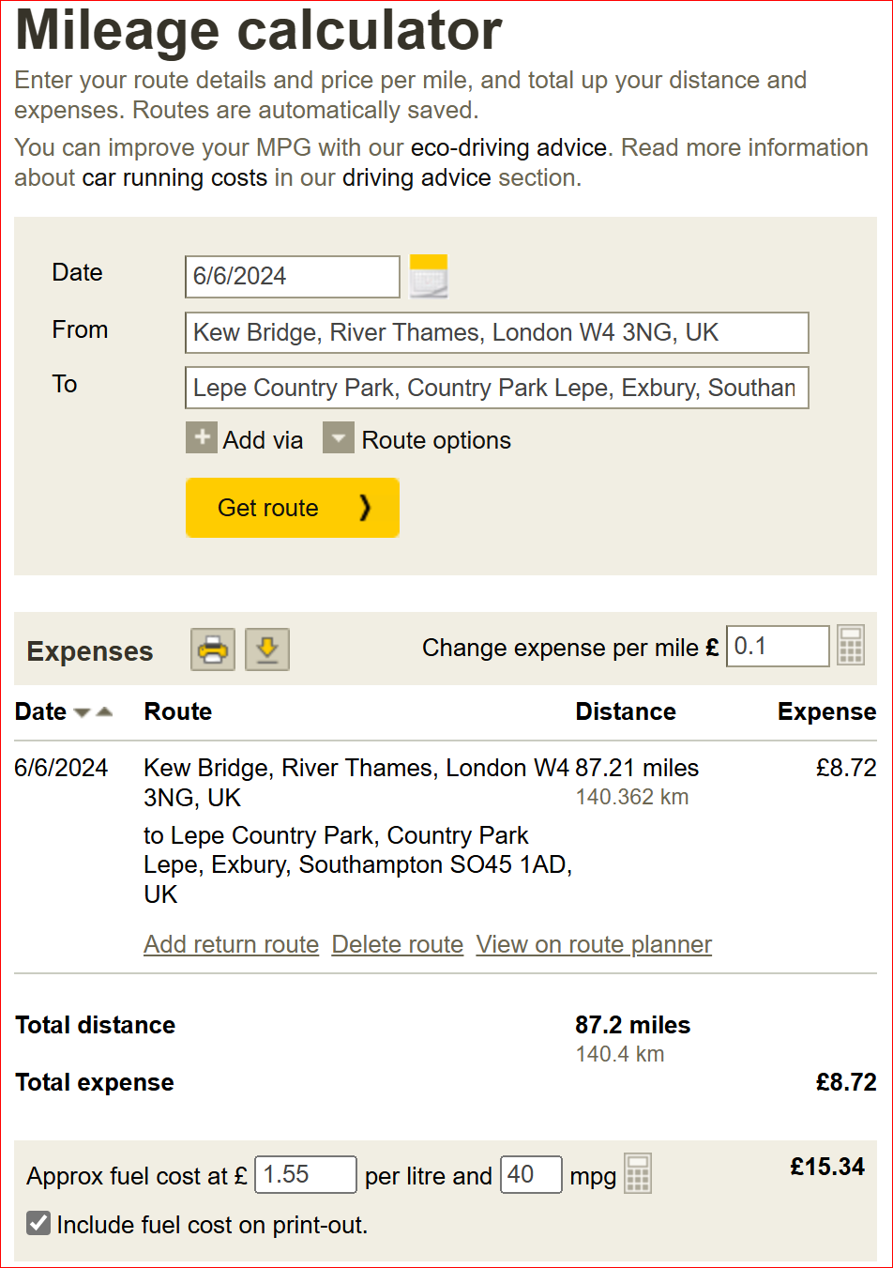
Since the trip is a return trip the costs are doubled:
Liza’s cost = (£14.59 + £8.72) * 2 = £46.62
Mike’s cost = (£14.59 + £8.72) * 2 = £46.62
David cost = (£15.34 + £8.72) * 2 = £48.12
Total trip cost is £46.62 + £46.62 + £48.12 = £141.36
The total trip cost is divided equally between the participants.
With 6 paddlers that is £23.56 per person. The 3 non-drivers each transfer this amount to one of the drivers.

Scenario 2 – trip to Lepe, one driver without club boats or passengers
- Liza takes 2 boats to Lepe and 1 passengers
- David takes 1 own boat and no passengers
- Mike takes 2 boats and 1 passenger
- The distance is 87.21 miles (each way). There are 5 people on the trip but one (David) has not carried club boats or passengers, so is excluded from the cost calculation.
- Mike and Liza’s cars are petrol, have an average of 38 mpg and fuel cost is £1.40.
From the AA Mileage Calculator,
- Mike and Liza’s the fuel cost is £14.59 and the expense cost is £8.72
Since the trip is a return trip the costs are doubled:
Liza’s cost = (£14.59 + £8.72) * 2 = £46.62
Mike’s cost = (£14.59 + £8.72) * 2 = £46.62
Total trip cost is £46.62 + £46.62 = £93.24
The total trip cost is divided equally between the participants.
With 4 paddlers using club boats, that is £23.31 per person. The 2 non-drivers each transfer this amount to the drivers.
Scenario 3 – trip to Onich, one driver with club boat and passengers
- David takes 2 boats and 2 passengers, leaving from Slough to Onich
- Damian takes no boats or passengers
- 2 other paddlers get the train.
- 4 kayaks are hired locally, the cost are shared equally between people without their own boats, regardless of how they travelled.
- The distance is 494 miles (each way). There are 6 people on the trip, but only 3 sharing the car journey.
From the AA Mileage Calculator,
- David’s fuel cost is £86.91 and the expense cost is £49.40
- Damian and the rail travellers do not get to share costs.
Since the trip is a return trip the costs are doubled:
David’s cost = (£86.91 + £49.40) * 2 = £272.62
The total trip cost is divided equally between the participants traveling together with boats.
With 3 paddlers that is £90.87 per person. The 2 non-drivers each transfer this amount to the driver.
Scenario 4 – trip to Dorset, one driver with club boat and passengers
- David takes 3 boats and 1 passenger, leaving from Slough to Dorset
- Gilly makes here own way to Dorset
- The distance is 228.5 miles (return). There are 3 people on the trip, but only 2 sharing the car journey.
From the AA Mileage Calculator,
- David’s fuel cost is £37.38 and the expense cost is £22.85.
- Gilly does not get to share her costs.
Since the trip is a return trip the costs are:
David’s cost = (£37.38 + £22.85) = £60.23
The total trip cost is divided between the participants in the following ratio:
- Independent traveller 60% of the cost to/from the Arches
- Passenger and driver have 100% of the cost
That means the total cost is divided by 2.6 (=100%+100%+60%) to give £23.17. The driver and the passenger pay £23.16, whereas the independent traveller pays 60% of this, or £13.90.
So, £23.17 +£23.17 + £13.90 = £60.24 (rounding gives an additional 1p)
The 2 non-drivers each transfer these amounts to the driver.

